**Module 8 : Portfolio Project**

M8 Documentation

Rawan Sadiq

Colorado State University Global

CSC450

Professor. Reginald Haseltine

October 6th, 2024

**Module 8 : Portfolio Project**

**Pseudocode:**

1. Create two classes, CountUp and CountDown, both implementing the Runnable interface.

2. In CountUp class, override run() method to:

a. Loop from 1 to 20, printing each count.

3. In CountDown class, override run() method to:

a. Loop from 20 to 0, printing each count.

4. In the main method:

a. Create two thread objects, one for each class.

b. Start the first thread (CountUp).

c. Wait for the first thread to finish.

d. Start the second thread (CountDown).

e. Wait for the second thread to finish.

5. End the program once both threads have finished.

**Source Code :**

package com.myproject.concurrency;

// Define the CountUp class that implements the Runnable interface for the first thread

class CountUp implements Runnable {

@Override

public void run() {

// Count up to 20

for (int i = 1; i <= 20; i++) {

System.out.println("Count Up: " + i);

try {

Thread.sleep(500); // Adding delay for better visibility

} catch (InterruptedException e) {

System.out.println("CountUp thread interrupted.");

}

}

}

}

// Define the CountDown class that implements the Runnable interface for the second thread

class CountDown implements Runnable {

@Override

public void run() {

// Count down from 20 to 0

for (int i = 20; i >= 0; i--) {

System.out.println("Count Down: " + i);

try {

Thread.sleep(500); // Adding delay for better visibility

} catch (InterruptedException e) {

System.out.println("CountDown thread interrupted.");

}

}

}

}

// Main class where thread creation and management happen

public class ConcurrencyCounter {

public static void main(String[] args) {

// Create thread objects for counting up and counting down

Thread thread1 = new Thread(new CountUp());

Thread thread2 = new Thread(new CountDown());

// Start the first thread (Count Up)

thread1.start();

// Wait for thread1 to finish before starting thread2

try {

thread1.join();

} catch (InterruptedException e) {

System.out.println("Thread join interrupted.");

}

// Start the second thread (Count Down)

thread2.start();

// Wait for thread2 to finish

try {

thread2.join();

} catch (InterruptedException e) {

System.out.println("Thread join interrupted.");

}

System.out.println("Both threads have finished execution.");

}

}

**Application:**

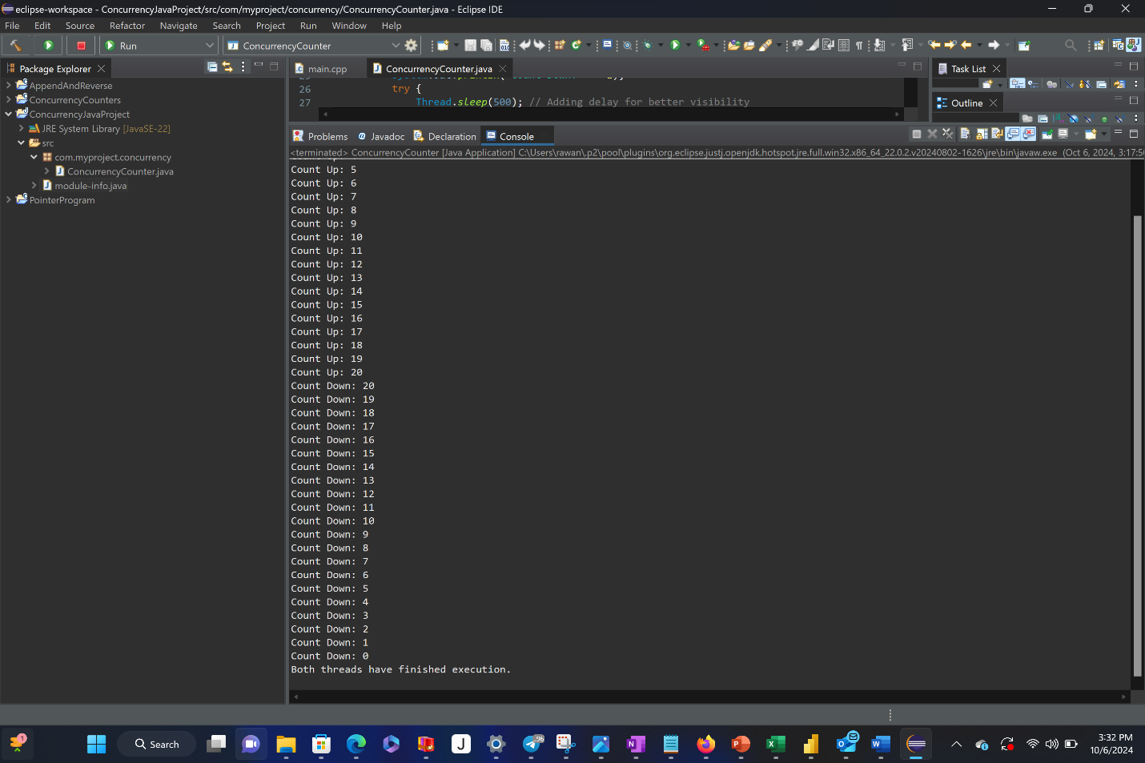

**Concurrency in Java and C++: A Comparative Analysis**

**Introduction**

Concurrency is a crucial aspect of modern programming, enabling applications to perform multiple tasks simultaneously and improving performance in multi-core processors. In this analysis, I compare the implementation of a simple concurrency-based program in both Java and C++. The program consists of two threads: one that counts up from 1 to 20 and another that counts down from 20 to 0. This comparison highlights the performance considerations, security vulnerabilities, and the overall security of the data types used in both languages.

**Performance Issues with Concurrency**

**Thread Management Overhead**

Java and C++ both provide robust support for concurrency, but their underlying mechanisms for thread management differ significantly. In C++, the std::thread class provides direct access to operating system threads, allowing low-level management of concurrency. This results in potentially higher performance in scenarios where minimal overhead is desired. C++ gives more control over thread creation and destruction, offering the ability to fine-tune the number of threads used, which is crucial for high-performance applications (Stroustrup, 2013).

However, the direct nature of thread management in C++ also increases the complexity of writing error-free code. Developers need to manage thread synchronization manually, which can lead to errors such as race conditions or deadlocks. For example, failing to properly join threads or protect shared resources with mutexes can result in unpredictable behavior.

In contrast, Java abstracts much of the low-level thread management through its Thread class and concurrency utilities like ExecutorService. This abstraction comes with some performance cost due to the overhead introduced by the Java Virtual Machine (JVM). The JVM manages threads at a higher level, adding features like automatic garbage collection and thread safety measures. However, this abstraction can slow down performance in scenarios where fine-grained control is needed (Goetz et al., 2006).

In the provided Java example, the threads are created using the Thread class, which implements the Runnable interface. This design allows the code to be simpler and easier to maintain. However, Java's thread management overhead means that for simple counting tasks, the performance may not match that of C++. Despite this, the JVM’s built-in optimizations, such as garbage collection and thread pooling, make Java suitable for scalable, enterprise-level applications where ease of use outweighs micro-level performance concerns.

**Synchronization and Race Conditions**

Both Java and C++ allow threads to run concurrently, but managing shared resources between threads can introduce performance bottlenecks. In C++, manual synchronization using locks and mutexes is required to prevent race conditions when threads access shared resources. Although this gives developers more control, it can slow down performance if too much time is spent acquiring and releasing locks.

Java mitigates this issue with built-in synchronization mechanisms, such as the synchronized keyword and higher-level constructs from the java.util.concurrent package, which can manage thread access to shared resources efficiently. These mechanisms abstract the complexity of synchronization, though they come with a slight performance cost due to the overhead of managing locks internally.

In both languages, thread synchronization is crucial to avoiding race conditions, but the higher level of abstraction in Java reduces the likelihood of developer error while increasing execution overhead. In high-performance applications that require minimal delay, C++ may be the better option.

**Vulnerabilities Exhibited with Strings**

**Immutability in Java**

In Java, the String class is immutable, meaning once a String object is created, it cannot be modified. This feature inherently provides a level of thread safety, as multiple threads can safely reference the same String object without concern for concurrent modifications (Bloch, 2018). However, this also comes with a performance cost. When concatenating or manipulating strings in Java, new String objects must be created, which increases memory usage and slows down execution.

For example, in a scenario where multiple threads need to append text to a shared String, the use of the StringBuilder class, which is mutable and provides better performance for concatenation, would be more efficient. StringBuilder is not thread-safe, but for single-threaded or local operations, it offers substantial performance improvements over the default String.

**Mutable Strings in C++**

In C++, strings are mutable by default. This provides better performance for scenarios involving frequent string manipulations because modifications can be made in place without creating new objects. However, this mutability introduces a significant vulnerability in concurrent applications. When multiple threads access and modify the same string, race conditions can occur unless proper synchronization mechanisms, such as locks, are employed.

For instance, if two threads attempt to modify the same string at the same time, the result could be corrupted data or even a program crash. In high-performance applications, developers must carefully manage string access, which increases complexity. While mutable strings provide better performance in single-threaded applications, they can introduce severe security and stability issues in multi-threaded contexts.

**Security of Data Types Exhibited**

**Data Types in Java**

Java provides several built-in mechanisms for ensuring data type safety in multi-threaded environments. Primitive data types like int, float, and boolean are inherently thread-safe when used in isolation. However, issues arise when these primitives are shared across threads, particularly if one thread is reading a value while another is writing to it. In these cases, the use of atomic variables, like those provided in the java.util.concurrent.atomic package, is necessary to ensure that operations are completed without interruption (Lea, 2000).

Java’s AtomicInteger class, for example, provides a thread-safe way to update integer values atomically without requiring synchronization. In contrast, using plain int variables in concurrent scenarios can lead to race conditions.

**Data Types in C++**

C++ provides more flexibility, but this comes at the cost of safety. Primitive data types in C++ are not inherently thread-safe, and it is up to the developer to manage synchronization. For example, if two threads try to increment the same integer simultaneously, the outcome may be unpredictable unless locks are used. This added complexity can lead to security vulnerabilities, such as race conditions, when data is accessed concurrently without proper synchronization.

While C++ offers atomic types like std::atomic<int>, these are not as widely used as Java's AtomicInteger class. Therefore, developers must be vigilant when managing shared data between threads to avoid security risks.

**Conclusion**

Both Java and C++ offer robust support for concurrency, but they differ in their approach to managing threads, handling strings, and ensuring data security. Java’s higher level of abstraction simplifies development and provides built-in safeguards, but this comes with a performance cost due to the overhead of the JVM and garbage collection. C++, on the other hand, offers greater control and potentially better performance in low-level applications, but requires developers to manage thread safety and synchronization manually.

When it comes to security, Java’s immutable String class and built-in atomic data types make it inherently safer for multi-threaded applications. C++ provides better performance for string manipulation but introduces security vulnerabilities in concurrent environments due to the mutable nature of its string handling and the manual synchronization required for shared resources. Ultimately, the choice between Java and C++ depends on the specific requirements of the application, including the need for performance, control, and security.

**References**

Bloch, J. (2018). Effective Java (3rd ed.). Addison-Wesley.

Goetz, B., Peierls, T., Bloch, J., Bowbeer, J., Holmes, D., & Lea, D. (2006). Java concurrency in practice. Addison-Wesley.

Lea, D. (2000). Concurrent programming in Java: Design principles and patterns (2nd ed.). Addison-Wesley.

Stroustrup, B. (2013). The C++ programming language (4th ed.). Addison-Wesley.